Project Development Phase Model Performance Test

|  |  |
| --- | --- |
| Date | 10 November 2022 |
| Team ID | PNT2022TMID28524 |
| Project Name | Natural Disaster Intensity Analysis and Classification using Artificial  Intelligence |
| Maximum Marks | 10 Marks |

# Model Performance Testing:

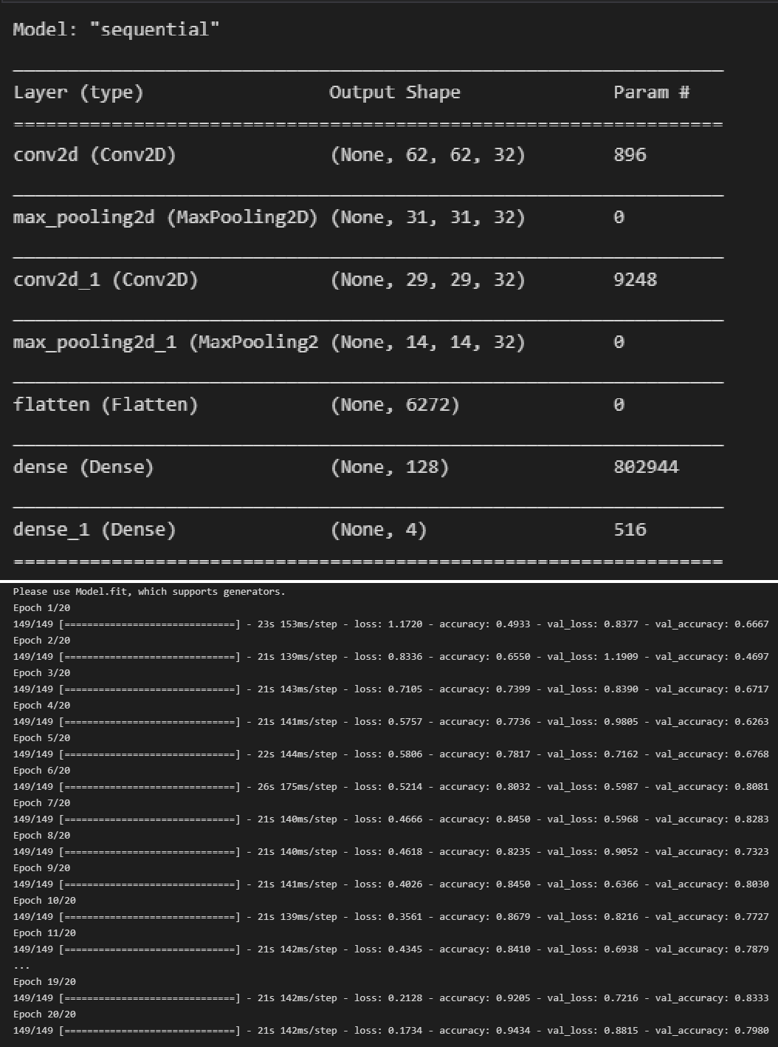Project team shall fill the following information in model performance testing template.

|  |  |  |  |
| --- | --- | --- | --- |
| **S.No.** | **Parameter** | **Values** | **Screenshot** |
| 1. | Model Summary | Total params: 813,604  Trainable params: 813,604  Non-trainable params: 0 |  |
| 2. | Accuracy | Training Accuracy – 94.3% Validation Accuracy -83.33% |  |

# A picture containing graphical user interface Description automatically generatedModel Summary:

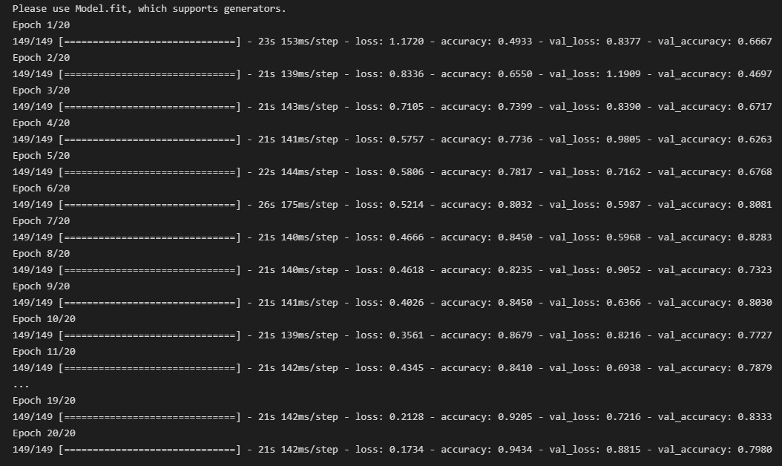**Accuracy:**